

COLLEGE ENQUIRY BOT

*A PROJECT REPORT*

*submitted by*

PRAGADEESHWARAN O

(22138009)

Under the guidance of

Mr.VASANTHARAJ K

Assistance Professor

Department of CSE

*In partial fulfilment for the award of degree of*

# BACHELOR OF TECHNOLOGY

**IN**

## COMPUTER SCIENCE AND ENGINEERING



**HINDUSTAN INSTITUTE OF TECHNOLOGY AND SCIENCE**

# CHENNAI -603 103

**MAY 2023**



# BONAFIDE CERTIFICATE

Certified that this project report COLLEGE ENQUIRY BOT

is the bonafide work PRAGADEESHWARAN O(22138009) who carried out the project work under my supervision during the academic year 2022-2023.

**SUPERVISOR**

Mr. VASANTHARAJ K,

Assistant Professor,

Department of CSE

**INTERNAL EXAMINER**

Name:

**EXTERNAL EXAMINER**

Name:

Designation: Designation: _

Project Viva - voce conducted on _

## TABLE OF CONTENTS

**CHAPTER TITLE**

|  |  |  |  |  |
| --- | --- | --- | --- | --- |
| **NO.** |  | **page NO** |  |  |
|  | **Acknowledgement** | **iii** |  |  |
|  | **Dedication** | **iv** |  |  |
|  |  |  |  |  |
| **1** | **INTRODUCTION** |  |  |  |
|  | 1.1 Abstract | 1 |  |  |
|  | 1.2 Motivation of the project | 1 |  |  |
| **2** | **LITERATURE REVIEW** |  |  |  |

2.1 Literature review 2

**3 PROJECT DESCRIPTION**

3.1 Objective 3

3.2 Existing system 3

3.3 Proposed system 3

3.4 Benefit of proposed system 3

**4 REQUIREMENTS**

4.1 Hardware and Software specification 4

4.2 Technologies Used 4

**5 SYSTEM DESIGN**

5.1 Architecture Diagram 5

**6 IMPLEMENTATION**

6.1 Source Code 6

6.2 Result and Analysis 8

**7 CONCLUSION AND FRAMEWORK**

7.1 Conclusion 10

7.2 References 10

**ACKNOWLEDGEMENT**

First and foremost we would like to thank ALMIGHTY who has provided us the strength to do justice to our work and contribute our best to it

We wish to express our deep sense of gratitude from the bottom of our heart to our

guide Mr. VASANTHARAJ K, Assistant Professor, Computer Science and Engineering, for his motivating discussions, overwhelming suggestions, ingenious encouragement, invaluable supervision, and exemplary guidance throughout this project work.

We would like to express our heartfelt gratitude to Dr.J.THANGA KUMAR, Associate Professor & Head, Department of Computer Science and Engineering

valuable suggestions and support in successfully completing the project .We also thank Dr. R.KANTHAVEL ,Dean, School of Computing for his support.

1. We wish to thank our Project Co-ordinator and Panel members for keeping our project in the right track. We would like to thank all the teaching, technical and non-technical staff of Department of Computer Science and Engineering for their courteous assistance.
2. We thank the management of HINDUSTAN INSTITUTE OF TECHNOLOGYAND SCIENCE for providing us the necessary facilities and support required for the successful completion of the project.

As a final word, we would like to thank each and every individual who have been a source of support and encouragement and helped us to achieve our goal and complete our project work successfully.

# DEDICATION

This project is dedicated to my beloved parents, for their love, endless support, encouragement and sacrifices.

**CHAPTER 1 INTRODUCTION**

## 1.1 ABSTRACT

A College enquiry bot is very essential these days for providing information to non-college/college students about the college.Many students do not have any information regarding the college and the information that is present online is very less and hence, less people know about the working of college and students become very uncertain whether to take admissions or not.

A college enquiry chatbot understands the user’s message, what type of information is being enquired and then it answers the query accordingly. The user can ask queries and the chatbot analyses the questions, interprets the meaning using a tag and intent and provides an answer.

The chatbot answers the questions as if it were answered by a human because the dataset it gets trained on contains many human-to-human conversations making it easier for the chatbot to understand the way humans converseThis system helps the student to be updated about the college activities and the non-students to gain information about various details about the college and its working

## Motivation of the project

## This bot could assist students in navigating their academic journey, providing information on course selection, degree requirements, registration deadlines, and even offering study tips or resources for academic success

**CHAPTER 2**

**LITERATURE REVIEW**

## INTRODUCTION:

Develop a chatbot, the main thing one should achieve is to create a chatbot that requires very little or say no human interaction at all. However, it is tough to improve answers and selecting best model to guarantee the most relevant response in the field of chatbots. The Aim of taking up this project is to provide a chatbot system that deals with academic activities like inquiring about admissions, fees structure, getting details of departments, etc. And using this chat-bot system, the freshers, students and faculty can directly clear their queries in lesser time.

# CHAPTER 3

**PROJECT DESCRIPTION**

## Objective

* To develop an intelligent interactive chatbot that is capable of interacting with the user and giving information about the various enquiries made by the user about the college.
* To answering queries for the user, the chatbot should be able to make a talk with the user making the user feel as if conversing with a human.
* To assign the user does not have to personally visit the college to enquire about the details and also can have a conversation about any topic if the user prefers.
* To provide input for the Chatbots which can create a user friendly chatbot with the mindset of questions typically enquired by users.
* To recommend a python based intelligent chatbot using Natural Language Processing libraries in Python so that the chatbot can interact with the user.
  1. **Existing system**
* OS windows 10
* 3GB RAM
* 3nd gen processor

II. ANATOMY OF EMAIL AND TYPES OF SPAM ATTACK

II. ANATOMY OF EMAIL AND TYPES OF SPAM ATTACK

II. ANATOMY OF EMAIL AND TYPES OF SPAM ATTACK

II. ANATOMY OF EMAIL AND TYPES OF SPAM ATTACK

II. ANATOMY OF EMAIL AND TYPES OF SPAM ATTACK

II. ANATOMY OF EMAIL AND TYPES OF SPAM ATTACK

II. ANATOMY OF EMAIL AND TYPES OF SPAM ATTACK

II. ANATOMY OF EMAIL AND TYPES OF SPAM ATTACK

II. ANATOMY OF EMAIL AND TYPES OF SPAM ATTACK

II. ANATOMY OF EMAIL AND TYPES OF SPAM ATTACK

II. ANATOMY OF EMAIL AND TYPES OF SPAM ATTACK

II. ANATOMY OF EMAIL AND TYPES OF SPAM ATTACK

II. ANATOMY OF EMAIL AND TYPES OF SPAM ATTACK

**3.3.** **Proposed system**

* + - * OS windows 8
      * 3GB RAM
      * 3nd gen processor

**3.4** **Benefit of proposed system**

ATTACK

* + - Fast boot time
    - Large storage space
    - Python is compatible with this system

II. ANATOMY OF EMAIL AND TYPES OF SPAM ATTACK

ANATOMY OF EMAIL AND TYPES OF SPThe nuisance of spamming will i almost all sorts of digital commthe present era. Among these, spamming through emails haalways been one of the most exploited arena for the fraudstersThis section depicts a detailed structure of the email itself and

ANATOMY OF EMAIL AND TYPES OF SPAM ATTACK

# CHAPTER 4

**4.1 Hardware and Software specification**

**Hardware**

* A pc or Laptop with following specification:
* 32 bit version of Microsoft windows 7,8,10
* 3GB RAM minimum, 1.5 GB hard disk space + at least 1GB for caches

**Software**

* Pycharm

**4.2 Technologies**

* Python libraries
* JSON

**CHAPTER-5**

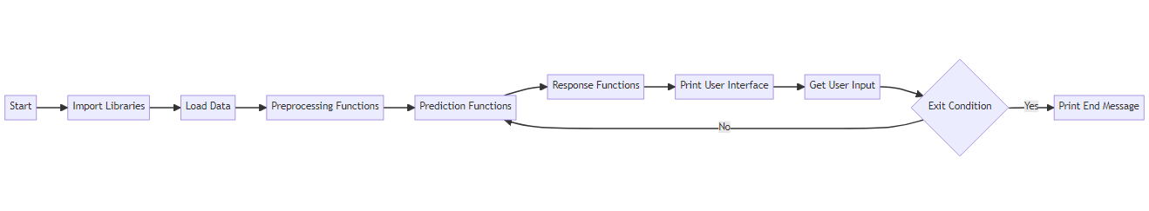

**CHAPTER-6**

**6.1 SOURCE CODE**

### College Project ###

import random

import json

import pickle

import numpy as np

import nltk

from nltk.stem import WordNetLemmatizer

from tensorflow.keras.models import load_model

lemmatizer = WordNetLemmatizer()

intents = json.loads(open('intents.json').read())

words = pickle.load(open('words.pkl', 'rb'))

classes = pickle.load(open('classes.pkl', 'rb'))

model = load_model('chatbotmodel.h5')

def clean_up_sentence(sentence):

sentence_words = nltk.word_tokenize(sentence)

sentence_words = [lemmatizer.lemmatize(word) for word in sentence_words]

return sentence_words

def bag_of_words(sentence):

sentence_words= clean_up_sentence(sentence)

bag = [0] * len(words)

for w in sentence_words:

for i, word in enumerate(words):

if word == w:

bag[i] = 1

return np.array(bag)

def predict_class(sentence):

bow = bag_of_words(sentence)

res = model.predict(np.array([bow]))[0]

ERROR_THRESHOLD = 0.25

results = [[i,r] for i, r in enumerate(res) if r > ERROR_THRESHOLD]

results.sort(key=lambda x:x[1], reverse=True)

return_list = []

for r in results:

return_list.append({'intent': classes[r[0]], 'probability': str(r[1])})

return return_list

def get_response(intents_list,intents_json):

tag= intents_list[0]['intent']

list_of_intents =intents_json['intents']

for i in list_of_intents:

if i['tag'] == tag:

result = random.choice(i['responses'])

break

return result

print("|============= Welcome to College Equiry Chatbot System! =============|")

print("|============================== Feel Free ============================|")

print("|================================== To ===============================|")

print("|=============== Ask your any query about our college ================|")

while True:

message = input("| You: ")

if message == "bye" or message == "Goodbye":

ints = predict_class(message)

res = get_response(ints, intents)

print("| Bot:", res)

print("|===================== The Program End here! =====================|")

exit()

else:

ints = predict_class(message)

res = get_response(ints, intents)

print("| Bot:", res)

# 6.5 RESULT AND ANALYSIS

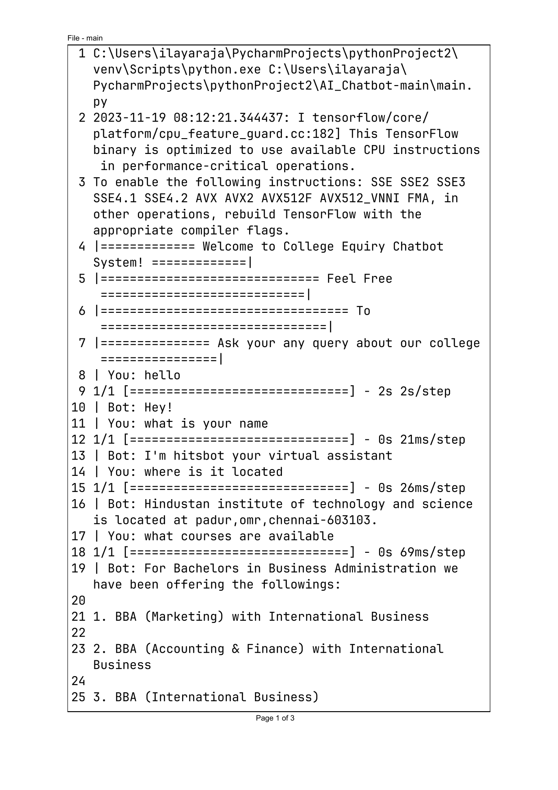

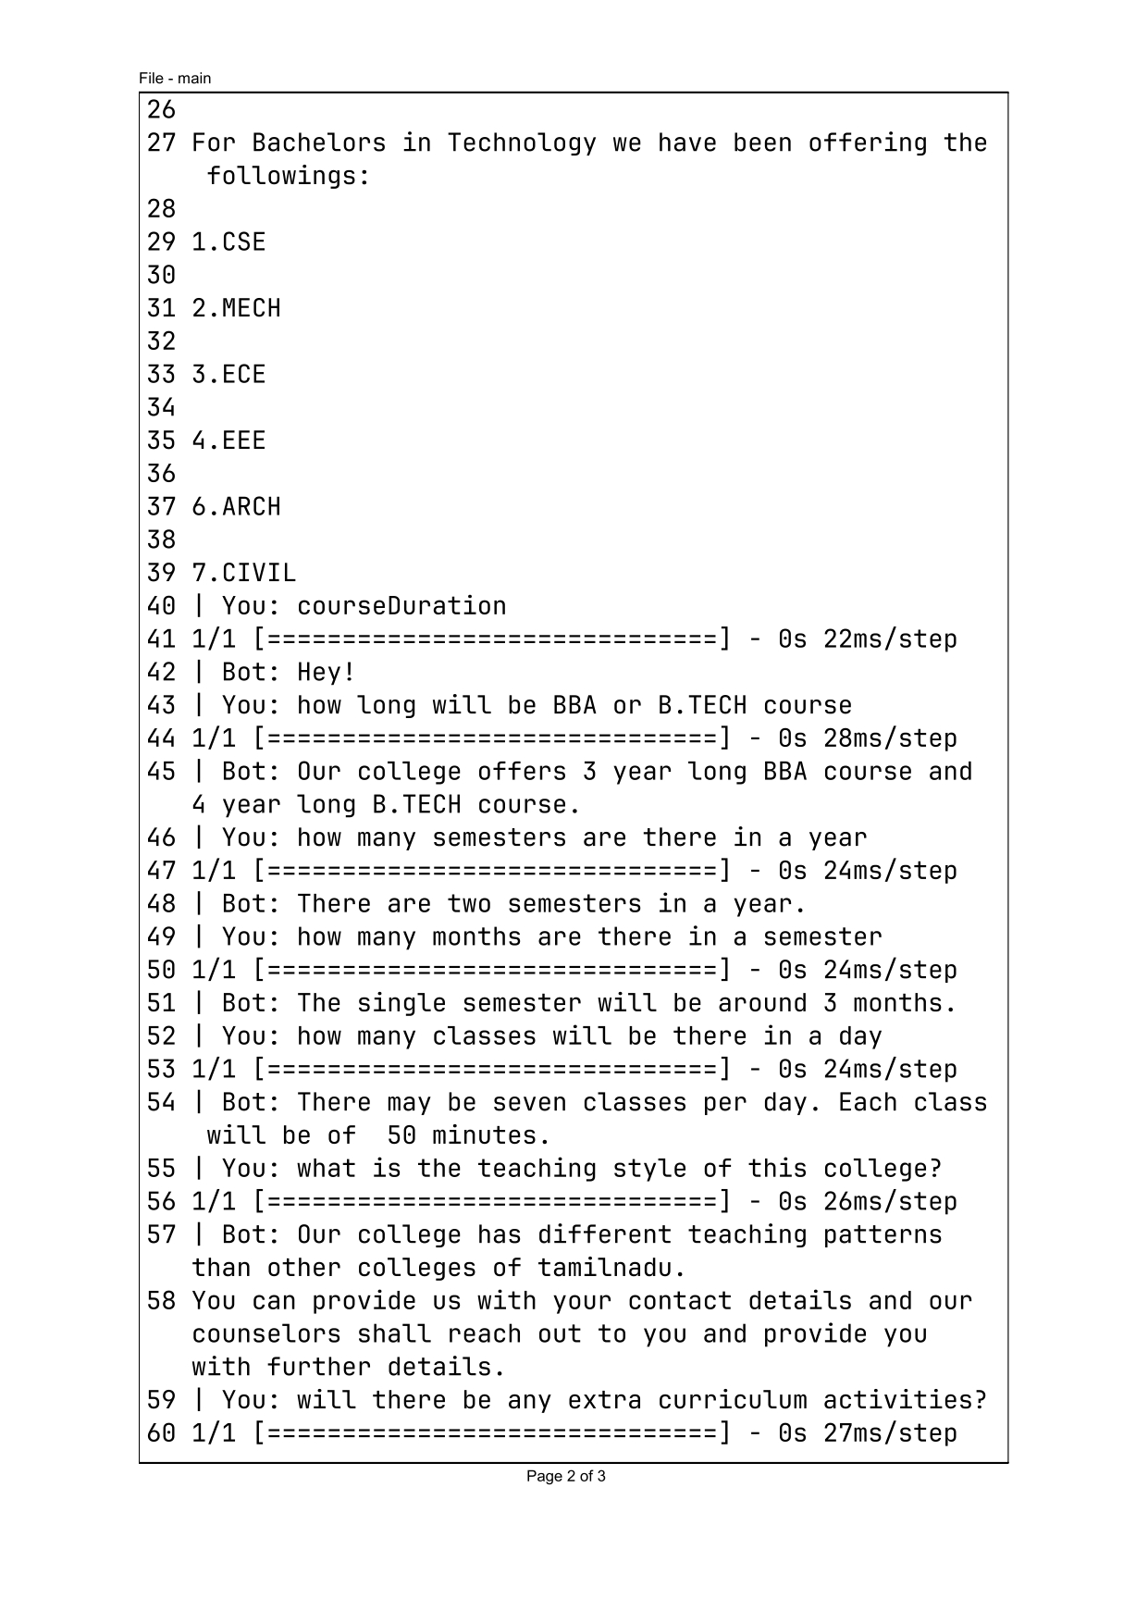



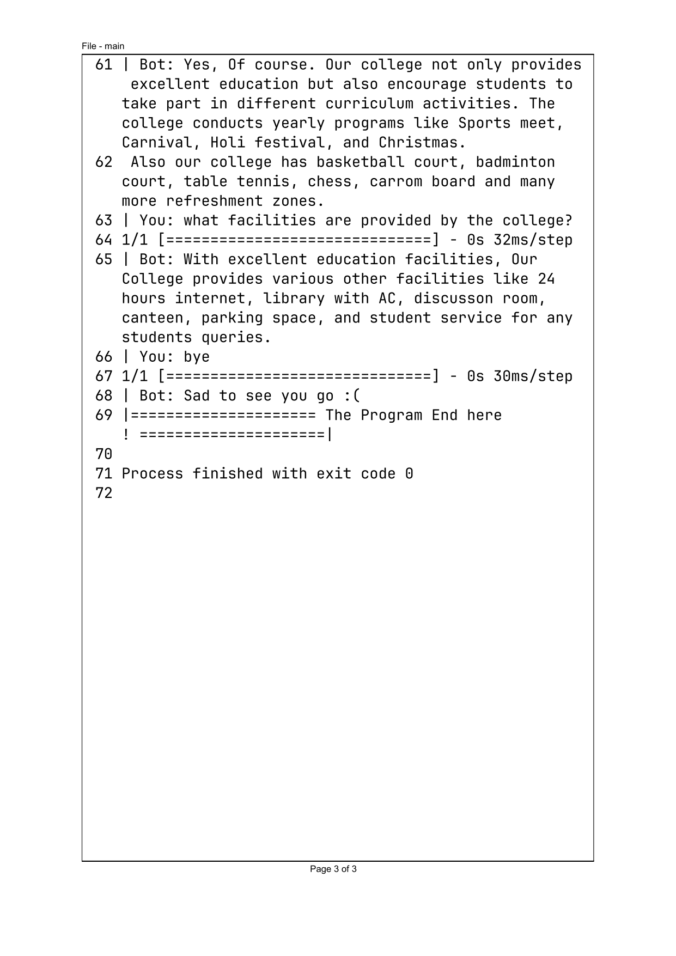

# CHAPTER 7

## 7.1 CONCLUSION

In this project we made a college specific chatbot system that can be custom fitted to education domain chatbot, the addition of this chatbot system in the college website will make the webpage more user interactive as it responds to the user queries very accurately as it is a domain specific chatbot system, and furthermore we had investigated our college chatbot system design stages and a few different techniques by which the precision of the chatbot system can be made much better. To make the responses given by the chatbot system more meaningful and accurate the administrator has to train the chatbot system with more information regarding to college and increase the scope of knowledge base. Nevertheless, gathering feedback from the potential user can be helpful in developing the college Chatbot system, ultimately servicing the user queries

**7.2 REFERENCES**

* An Interactive Chatbot for College Enquiry Journal of Computing and Communication Vol.2 , No.1 , PP. 20-28 , 2023
* College Enquiry Chatbot using Conversational AI International Journal for Research in Applied Science & Engineering Technology (IJRASET) ISSN: 2321-9653; IC Value: 45.98; SJ Impact Factor: 7.538 Volume 11 Issue V May 2023